Spain’s Heart & “Sol”

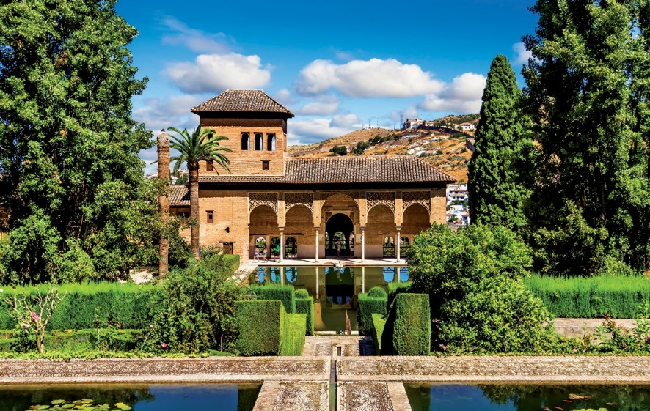

GRANADA

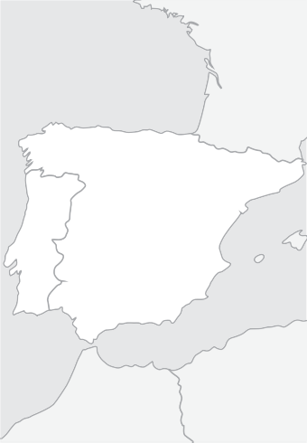

Granada

Seville

Córdoba

Mérida

Madrid

**SPAIN**

**Guaranteed Departure Tours**

**Spain & Portugal**

# From 505 €

7 days / 6 nights

Madrid - Merida - Seville - Cordoba - Granada.

## Departures from Madrid:

**Sunday**

**2019**

|  |  |
| --- | --- |
| March | 31 |
| April | 07, 14, 21, 28 |
| May | 05, 12, 19, 26 |
| June | 02, 09, 16, 23, 30 |
| July | 07, 14, 21, 28 |
| August | 04, 11, 18, 25 |
| September | 01, 08, 15, 22, 29 |
| October | 06, 13, 20, 27 |
| November | 03, 10, 24 |
| December | 08, 22, 29 |
| 2020 |  |
| January | 05, 19 |
| February | 02, 16, 30 |
| March | 08, 15, 22, 29 |
| April | 05, 12, 19, 26 |

### Day 1, Sunday: MADRID

Arrival at Madrid airport. After clearing sim- ple immigration and customs formalities, you will be transferred to your First Class hotel. It is suggested you take advantage of the free time to get to know one of Europe’s most dynamic capital cities. In the early evening, enjoy an “Illuminated Madrid” drive through

ing attractions, like the Puerta del Sol, the

magnificent fountains of Neptune and Cibe- les, the stately Alcala Gate, the busy Gran Via, the Plaza de España and the Plaza de Oriente. Free time for lunche on on your own. PACKAGE includes a Lunch today. Highly recommended this afternoon, is an optional tour to the Imperial former capital city of Toledo, where you will be escorted through its narrow cobblestone streets, soaking up the medieval atmos- phere. Touring will include the interior of the magnificent Gothic cathedral and a visit to St. Tome Church, where El Greco’s master- piece painting is displayed. There will also be some time for shopping for the unique typical local artisanry. PREMIUN PACKAGE includes the tour to Toledo Return to Ma- drid for accommodations.

### Day 3, Tuesday: MADRID - ME- RIDA - SEVILLE

Buffet breakfast. Departure through the once-remote region of Extremadura, home to many of the “conquistadors”. Arrival in ancient Merida. Free time for lunch. (Lunch

minaret). Free time for lunche on your own.

(Lunch Included in PREMIUN PACKAGE) The afternoon is free to continue to explore or shop. This evening an optional Flamenco Show is suggested, with the enjoyment of local wine. PACKAGE include Flamenco Show and drink. Accommoda- tions.

### Day 5, Thursday: SEVILLE - COR- DOBA - GRANADA

Buffet breakfast. Depart to Cordoba. Visit one of the world’s marvels, the former Great Mosque (now a cathedral). Free time for lunch on your own. Continue to Granada, passing thousands of acres of olive groves. PACKAGE includes dinner to- night. This evening, an excellent suggestion would be to visit (optional) the quaint and typical Albaicin quarter, where Andalusian customs, music and wine join to create an enchanting atmosphere. (PACK- AGE includes this visit).

### Day 6, Friday: GRANADA - MA- DRID

April 01-14, 2019

|  |  |
| --- | --- |
| HOTELS USED  or similar | |
| Category Confort Hotels | |
| Madrid  Seville Granada Madrid | Praga /Holiday Inn Piramides  Muralto / Chamartin  M.A. Sevilla Congresos Abades Nevada Palace Praga /Holiday Inn Piramides Muralto / Chamartin |
| Category Superior Hotels | |
| Madrid Mayorazgo / Cuzco / Agumar  Rafael Atocha Seville Melia Lebreros Granada G.H. Luna / Saray  Madrid Mayorazgo / Cuzco / Agumar Rafael Atocha | |
| Price per Person in Euros In Double / Twin room | |
| Tour 7 days: Madrid / Madrid | |
| Category Confort Hotels | |

April 21 / June 23

June 30 / August 25

September 01 / October 20

October 27 / March 22, 2020

March 29, 2020 / April 26, 2020

Supl. Single Room Apr 1/Oct 31,2019 + Apr 2020 Supl. Single Room Nov 1, 2019 / Mar 31, 2020

650

550

510

550

505

580

235

190

the bustling streets of the old city, ending

at the historical and impressive Plaza Mayor. This area is home to some of the most typi- cal restaurants and taverns, which serve the delicious “tapas”. PACKAGE includes a Tapas Dinner tonight. Return to your hotel at your own convenience. Ac- commodations.

### Day 2, Monday: MADRID

Buffet breakfast. This morning’s escorted sightseeing tour will allow you to get a glimpse of some of Madrid’s most outstand-

included in PACKAGE.) In the afternoon, visit the impressive Roman am- phitheatre archeological site before contin- uing to Seville.Accommodations.

### Day 4, Wednesday: SEVILLE

Buffet breakfast. This morning’s marvelous tour will explore this gracious and charming city, Spain’s third largest. See the Tower of Gold, the tranquil and extensive Maria Luisa Park, the quaint Santa Cruz Quarter, and fi- nally the huge cathedral (one of the world’s largest) with its Giralda Tower (a former

Buffet breakfast. This morning, enjoy an

escorted tour of the magnificent Alhambra and the verdant Gardens of the Generalife. Departure to Madrid, crossing the Plains of La Mancha, land of Don Quixote. Arrival in Madrid. Accommodations.

|  |  |
| --- | --- |
| April 01-14, 2019  April 21 / June 23  June 30 / August 25  September 01 / October 20  October 27 / March 22, 2020  March 29, 2020 / April 26, 2020  Supl. Single Room Apr 1/Oct 31,2019 + Apr 2020 Supl. Single Room Nov 1, 2019 / Mar 31, 2020 | 690  620  565  620  580  650  300  270 |

### Day 7, Saturday: MADRID

Buffet breakfast. Pre-arranged transfer to Madrid airport at the proper time to check-in for your trans-Atlantic flight to your home city (usually via connection). Arrival later the same day.

Category Superior Hotels

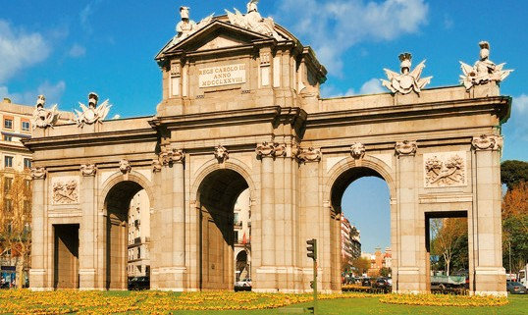

#### TOUR FEATURES

P Transfers airport-hotel-airport

P Accommodations in hotels of Category Confort or Superior

P Bountiful buffet breakfast daily

#### OPTIONAL PACKAGE INCLUDES

**7 DAYS:** MADRID / MADRID: **155 €** · INCLUDES 5 MEALS AND 3 EXTRAS

P Deluxe air-conditioned motorcoach transportation

P Professional tour escort throughout (bilingual English/Spanish)

P Escorted sightseeing tours with bilingual guide in Madrid, Granada, and Seville

P Entrace to Alhambra

P Evening Illuminations tour of Madrid

P Travel bag

P “Tapas” dinner in Madrid P Lunch in Madrid or Toledo P Tour to Toledo

P Lunch in Merida

P Lunch in Seville

P Dinner in Granada

P Tour-Show of the Albaicin in Granada

P Flamenco show in Seville



### 6